Local Network Traffic

1. ARP:

sudo tcpdump -i <interface> arp -n

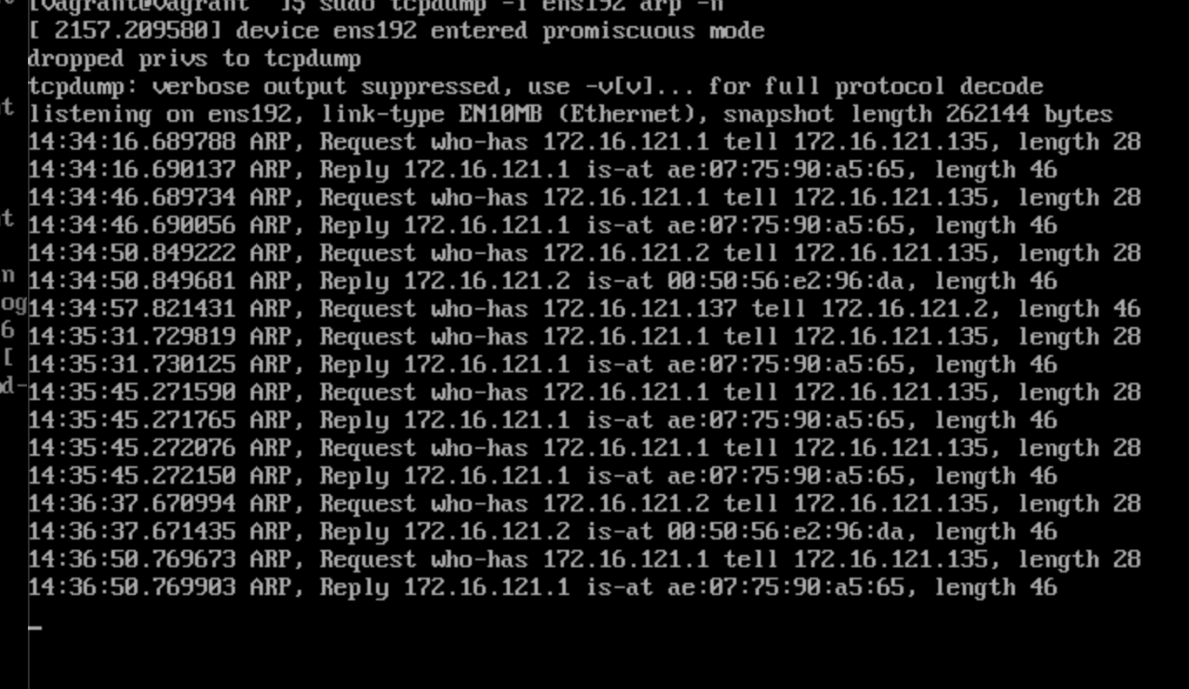

sudo ip -s -s neigh flush all

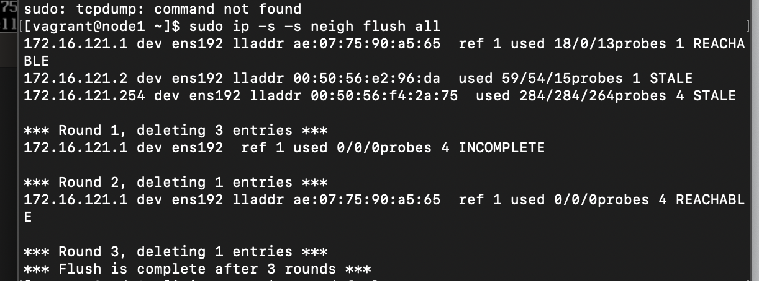

ip route | grep default

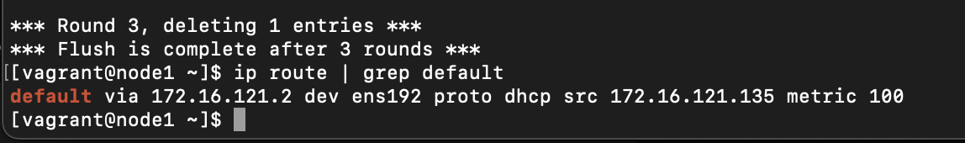

ping -c 1 <default_gateway_ip>

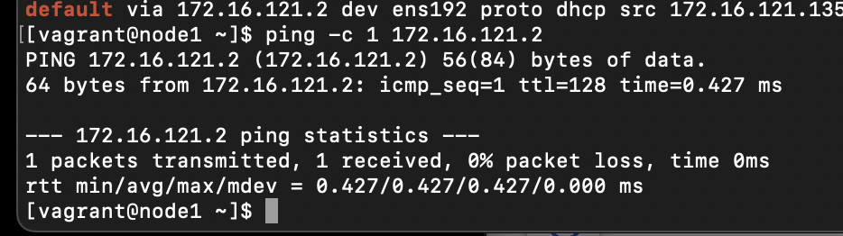

1. ICMP:

sudo tcpdump -i <interface> icmp

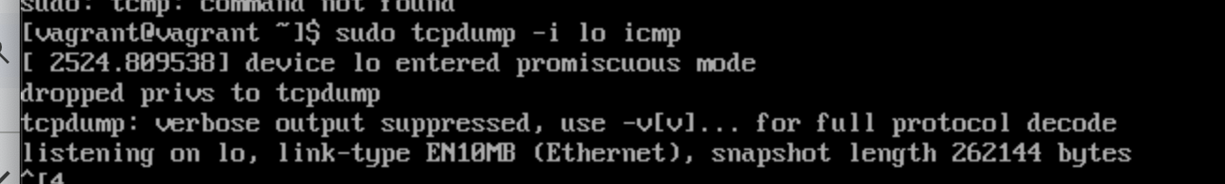

ping -c 5 8.8.8.8

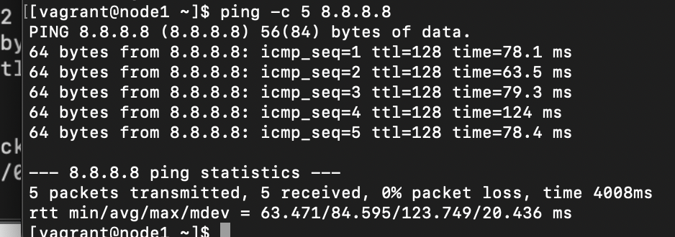

1. TCP, HTTP:

sudo tcpdump -i <interface> tcp port 80 and host neverssl.com -A

curl <http://neverssl.com/>

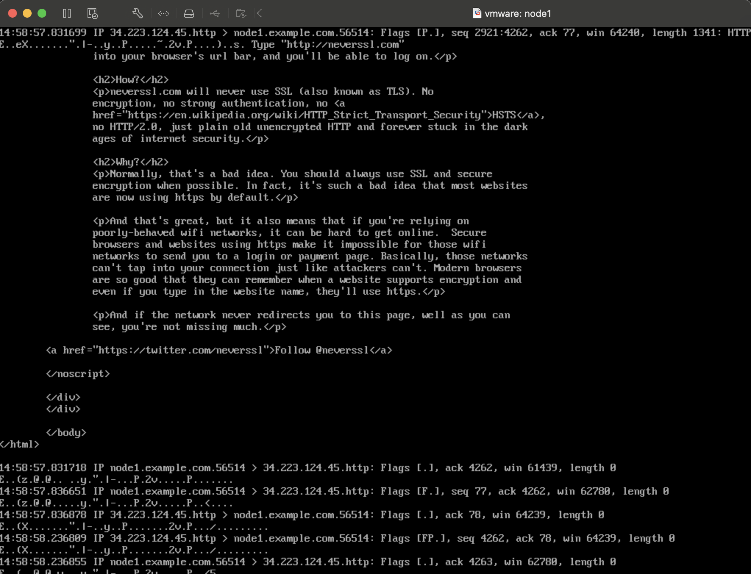

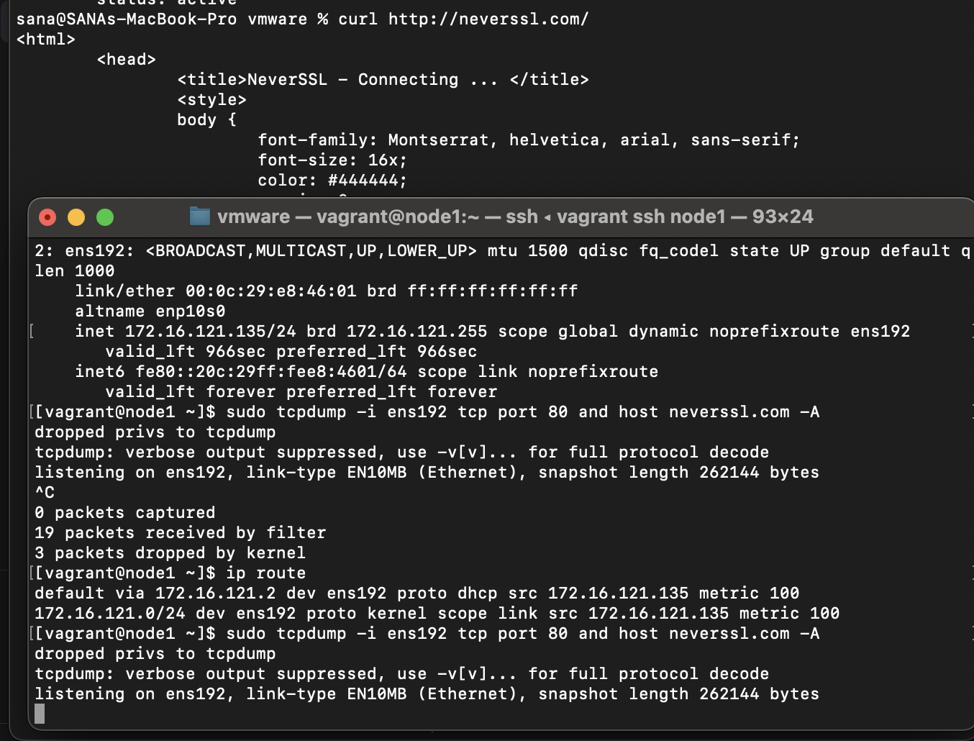

Default <interface> value for me is ens192